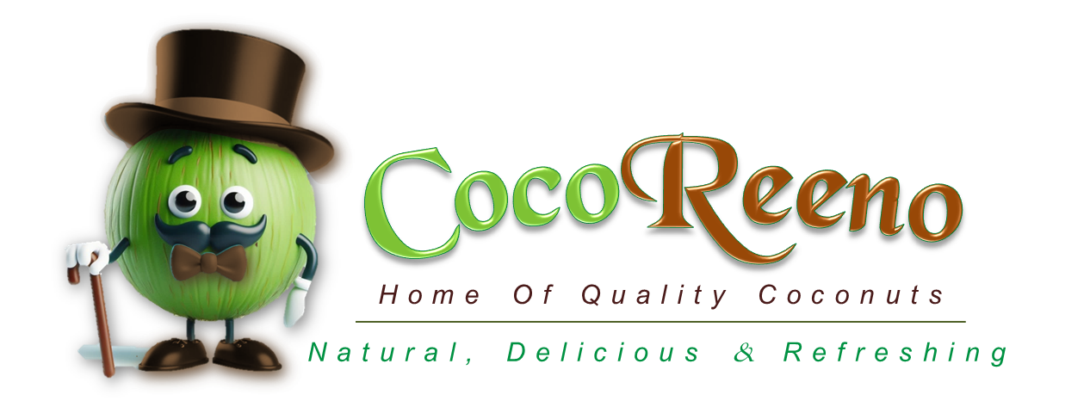

# EXECUTIVE SUMMARY

CocoReeno Enterprise is an integrated coconut development company that is socio-economic in nature, technologically advanced, and has sustainability at its core. It is committed to revolutionizing the coconut industry in Ghana, Africa, and globally, by leveraging innovation, sustainability, and community impact. Its mission is to create significant value from coconuts while improving the livelihoods of smallholder farmers, *through technology and innovation*. That is why the project has been aptly named as:

**Ghana Coconut Enterprises Development Initiative (G-CEDI)**

*“CocoVation: Reshaping The Coconut Industry Through Technological Innovations, Sustainability and Inclusive Growth”.*

Through the themes of the project, and a strong partnership with the **Tree Crop Development Authority (TCDA)**, CocoReeno aims to transform the entire coconut value chain; addressing key industry challenges and driving economic growth.

**Project Goals and** **Objectives:**

The G-CEDI is CocoReeno’s flagship project, aimed at modernizing the coconut value chain. By integrating advanced technologies with an AI-driven supply chain management, the company will enhance efficiency, reduce waste, and improve product quality. The project encompasses the following aspects of the coconut industry: *farming, harvesting, processing, marketing, sales, and waste valorization*. It offers a comprehensive solution to the challenges facing each of those areas.

**Technology, Innovation and Digitalization:**

CocoReeno’s key innovations include advanced *peeling machines, beautifully designed sales carts* and *sales backpacks*, a *QR code tracking system* and a *fleet management system* integrated with AI technology used for data analysis and operations optimization. These technologies are going to digitalize operational records through real-time tracking systems, data collection, seamless integration and analytics. They will also allow for personalization in e-commerce, and digital marketing. Adopting such initiatives, will not only enhance operational efficiency but also set new standards for the industry in terms of operational efficiency and customer engagement.

**Job Creation:**

A strong emphasis is placed on youth employment and skills development. The G-CEDI project is expected to create over 7,000 jobs nationwide through a detailed analysis of labour requirements in the farming, processing, and distribution sectors, scaled up by the projected market demand. Additionally, an increase in smallholder farmers’ incomes by **10%** within three years, and a reduction in post-harvest losses by **15%** is anticipated within the same period. Thus establishing the project is socio-economically impactful.

**Marginalized Groups:**

To address historical inequalities and contribute to a more inclusive society, *youth, women, and people living with disabilities* are prioritized in CocoReeno’s employment and training opportunities in alignment with its social equity goals. This demonstrates the company’s commitment to inclusive economic growth and community empowerment.

**Sustainability:**

Sustainability is at the core of CocoReeno’s operations. It is dedicated to reducing its environmental footprint and cut its carbon emissions by 10% annually. It is going to achieve this through sustainable farming practices *(organic farming, agroforestry, waste management, water conservation),* and renewable energy integration.

**Rural Development:**

CocoReeno is already involved in the boosting of rural businesses through its sourcing of coconuts from communities. By promoting value-added coconut products and supporting local enterprises, the company aims to stimulate rural economic growth and improve the livelihoods of farmers and workers. CocoReeno’s commitment to sustainable agricultural practices further strengthens the resilience of these communities, contributing to long-term development.

**Experienced Team:**

CocoReeno's management team, boasts of over 56+ years of experience in business development, rural development, and coconut industry operations. Their combined expertise in strategic planning, management, and innovation, coupled with a strategic vision, ensures a comprehensive approach to improving the coconut industry in a way that is aligned with inverstor’s goals. The team will further be supported by highly-accomplished consultants to ensure that the best and most impactful results are always achieved.

**Financial** **Sustainability:**

The project will be self-sustaining but only needs to be supported at the initial stage. Financial projections indicate an expected revenue of **GHC 17.2 million** in **Year 1 growing at a CAGR of 5.27% to reach GHC 21.1 million** by **Year 5. B**reak-even point is anticipated within **24 months.** The projected ROI is **48%** in **Year 1 growing at a CAGR of 8% to reach 67%** by **Year 5**. These metrics are supported by robust demand forecasts, cost optimization strategies, and diversified revenue streams from value-added coconut products

**Alignment with TCDA Goals:**

CocoReeno is more than just a coconut company; it is a catalyst for change in the coconut industry and beyond. It is setting the stage for a new era in coconut production.

The G-CEDI project’s objectives align closely with TCDA’s priorities, particularly in *promoting sustainable agriculture, enhancing value addition, and improving smallholder farmer livelihoods.* CocoReeno’s emphasis on technology-driven efficiency, rural development, and market expansion directly supports TCDA’s strategic goals of *industry modernization and global competitiveness.*

National **Contributions:**

CocoReeno's sustainability initiatives directly support Ghana’s Nationally Determined Contributions (NDCs) under the Paris Agreement, contributing to the country’s environmental goals. Also, its alignment with national rural development goals, such as the Ghana Community-Based Rural Development Project of the World Bank, ensures that the company’s efforts support broader societal objectives.

**Conclusion:**

CocoReeno invites the **TCDA** to join forces in this transformative venture to unlock the full potential of Ghana's coconut industry and transform it into a global leader. Through that, we will create lasting impacts for farmers, communities, and the environment, even beyond the coconut industry and contribute to a broader agricultural development.

# ABOUT COCOREENO

## Overview of CocoReeno

CocoReeno Enterprise is an integrated coconut development company that is socio-economic in nature, technologically advanced, and has sustainability at its core. It is a pioneering coconut development company committed to revolutionizing the coconut industry in Ghana, Africa, and globally.

* **Mission:** To create significant value from every part of the coconut fruit *through technology and innovation,* whilst improving the livelihoods of smallholder farmers*.*
* **Vision:** To create an enhanced coconut value chain that is built on *innovative technologies, sustainable practices,* and *strategic market expansion*, that set new standards for *quality, efficiency,* and *environmental responsibility.*
* **Goal:** To expand Ghana’s coconut industry through pioneering ventures that contribute to *socio-economic growth, job creation*, and *environmental* sustainability.

With a focus on cutting-edge technologies, market expansion, value addition and a deep industry expertise, CocoReeno is well-equipped to address the challenges facing the coconut sector and unlock its full potential.

## Problem Statement and Solutions

### Problem Statement

The Ghanaian coconut industry is facing several challenges, including post-harvest losses, limited value addition, and inadequate market access. These issues hinder the industry's growth potential and its ability to compete globally. Additionally, smallholder farmers lack the necessary resources and knowledge to implement sustainable farming practices, leading to low productivity and environmental degradation.

### CocoReeno’s Solutions

The company proposes a multifaceted approach to address these challenges. Its recommended interventions directly address these challenges through innovative and sustainable approaches:

1. **Reduction of Post-Harvest Losses:** By introducing advanced processing technologies, like CocoReeno’s coconut peeling machine, and efficient supply chain management, CocoReeno aims to reduce post-harvest losses significantly. Its state-of-the-art processing facilities will ensure that coconuts are quickly and efficiently transformed into high-quality products, thereby minimizing waste and maximizing value. CocoReeno’s value-added output is projected to increase by **15%** over the next three years *(Supported by FAO, 2023; verified by ResearchAndMarkets).*
2. **Value Addition through Innovation:** CocoReeno is committed to moving beyond raw coconut sales by developing a range of value-added products such as *coconut oil, coconut water, and coconut flour.* These products not only command higher prices but also meet the growing demand for healthy, organic food options in both local and international markets. This will increase the industry's value-added output significantly over the next five years *(Supported by World Bank, 2023; verified by Mordor Intelligence).*
3. **Market Development and Expansion:** CocoReeno will leverage modern branding and marketing strategies to improve the visibility and appeal of Ghanaian coconut products. By building strong market linkages and ensuring consistent product quality, the company will enhance the competitiveness of its products in high-value markets, both locally and globally. CocoReeno aims to increase Ghana’s coconut product exports significantly within the next five years *(Supported by ITC, 2023; verified by FAO).*
4. **Capacity Building for Farmers:** CocoReeno will implement training programs for 1,000 smallholder farmers annually, focusing on sustainable farming practices and efficient resource management. This initiative is expected to boost coconut yields significantly within five years and reduce environmental impact *(Supported by GSS, 2023; verified by 6Wresearch).*

## Growth Opportunities

CocoReeno is strategically positioned to capitalize on the robust growth of the coconut industry in Ghana and Africa. The company can leverage its innovative practices, such as the use of peeling machines and beautifully designed sales carts, to differentiate its products in the market.

Furthermore, CocoReeno’s commitment to branding its salespersons and integrating technology through QR codes for sales tracking will enhance operational efficiency and consumer engagement.

The TCDA’s support for the coconut industry in Ghana, with a projected revenues of **$2 billion** annually *(GSS, 2023; verified by ResearchAndMarkets),* provides a solid foundation for CocoReeno’s growth.

By aligning with TCDA’s objectives, CocoReeno hopes to access funding, technical assistance, and market linkages that will enable the company to scale its operations and expand its market reach.

## A Vision for a Brighter Future

CocoReeno is not just about coconuts - it’s about transforming lives, building futures, and igniting hope in every community it touches. The G-CEDI project is the embodiment of this vision, and CocoReeno is committed to making it a reality - one coconut at a time.

This story is only the beginning. As CocoReeno continues to grow and expand its reach, the company remains dedicated to its mission of creating a sustainable, thriving coconut industry that benefits everyone involved - from the farmers in rural Ghana to the consumers who enjoy the fruits of their labour.

**WHAT YOU SHOULD KNOW ABOUT MY VISION FOR COCOREENO**

CocoReeno Enterprise is an integrated coconut agribusiness company in Ghana. I want to build it such that it will attract a lot of funding and investors.

My vision is to grow it as the biggest coconut company or the No.1 in Ghana, Africa and globally, and I want to be known as one of the authorities in the coconut industry.

The Ghana Coconut Enterprises Development Initiative (G-CEDI) is a flagship project of CocoReeno.

CocoReeno Enterprise:

➢Has the potential to generate a lot of revenue as well as a lot of employment.

➢Can be aligned with the aims, objectives, mission and vision of a lot of programs of government and other organizations.

Some of our innovations:

➢ Use peeling machines: Shape tender coconuts into diamond shapes.

➢ Sales carts: Beautifully designed - like coco express.

➢ Brand our salespersons.

Feel free to add your own innovations and technologies.

CocoReeno plans to change the face of the coconut industry through new innovations and integrating operations with technology.

➢ Special chips for sales retirement.

➢ QR codes for sales tracking.

That will enhance effective revenue mobilization and monitoring.

Also improve operational efficiency.

Hence, I should be constantly educated on the latest technologies in terms of farming, harvesting, transporting, processing and sale of coconuts.

I also intend to export coconut and coconut products. Hence, I need to be building CocoReeno to be export ready inasmuch as I build it for local dominance.